**United International University**

***Department of Computer Science and Engineering***

**Submitted to: Md Abdullah Al Maruf**

**Course Code : CSI 424 (Simulation Lab)**

**Name : Hamudi Hasan Sonet**

**ID : 011 132 033**

**Section : B**

**Lab Report : 01 ( Random Number )**

**Date : 24 October 2016**

Problem Definition :

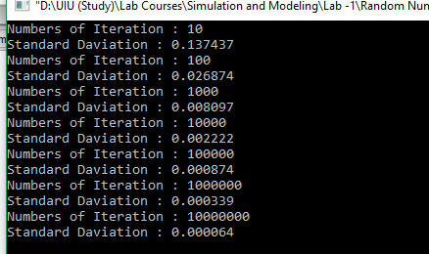

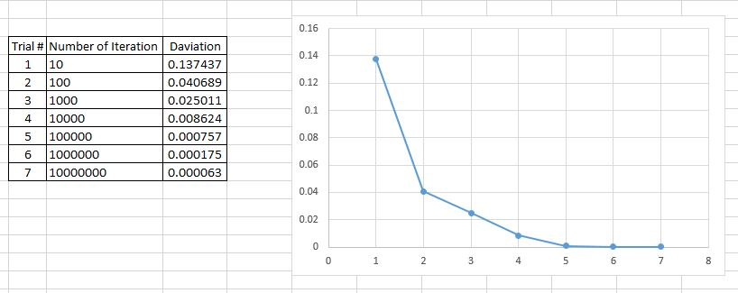

From above output and graph we can easily understand that when we increase the number of iteration, then standard deviation and error rate decreases. At the point 10 the rate is so high and at the point of 10000000 the rate is almost zero, if we could try is for infinite iteration then there would be no error.

This happens because we know in we increase number of trail then the probability increases. Suppose if we want to calculate the average height of all UIU students (suppose UIU has 4000 students). If we calculate heights of 100 students then we will get less accurate value, if we calculate 4000 student’s height then we will get the accurate average height. So increasing the trail / number will decrease the error.